Rhyming Dictionary

What is Rhyming Dictionary
# Source: AI Source: Provided by: [Data Path: Persons Table -> ID Column: 1, Name_En Column: Motasem Essam] -> From: [Chatgpt (GPT-4-turbo)] on [7/29/2025]
A Rhyming Dictionary is a specialized reference that lists words grouped by their rhyming endings rather than alphabetically. It is especially valuable for poets, lyricists, songwriters, and anyone involved in creative or phonologically patterned writing.

🔹 Key Features of a Rhyming Dictionary
# Source: AI Source: Provided by: [Data Path: Persons Table -> ID Column: 1, Name_En Column: Motasem Essam] -> From: [Chatgpt (GPT-4-turbo)] on [7/29/2025]
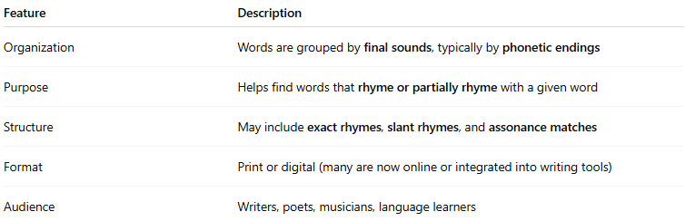
Feature | Description
Organization | Words are grouped by final sounds, typically by phonetic endings
Purpose | Helps find words that rhyme or partially rhyme with a given word
Structure | May include exact rhymes, slant rhymes, and assonance matches
Format | Print or digital (many are now online or integrated into writing tools)
Audience | Writers, poets, musicians, language learners

🔹 Types of Rhymes Covered
# Source: AI Source: Provided by: [Data Path: Persons Table -> ID Column: 1, Name_En Column: Motasem Essam] -> From: [Chatgpt (GPT-4-turbo)] on [7/29/2025]
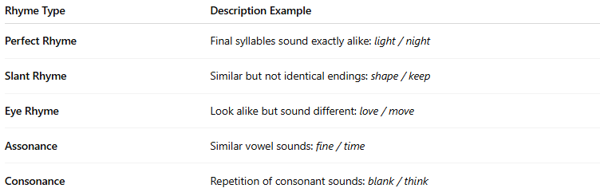
Rhyme Type | Description Example
Perfect Rhyme | Final syllables sound exactly alike: light / night
Slant Rhyme | Similar but not identical endings: shape / keep
Eye Rhyme | Look alike but sound different: love / move
Assonance | Similar vowel sounds: fine / time
Consonance | Repetition of consonant sounds: blank / think

🔹 Examples of Rhyming Dictionaries
# Source: AI Source: Provided by: [Data Path: Persons Table -> ID Column: 1, Name_En Column: Motasem Essam] -> From: [Chatgpt (GPT-4-turbo)] on [7/29/2025]
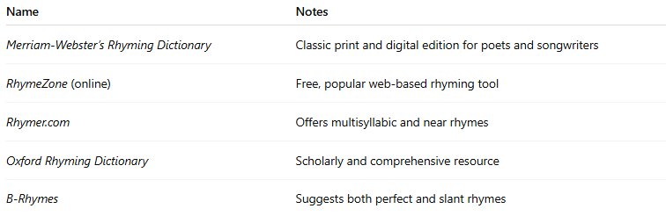
Name | Notes
Merriam-Webster’s Rhyming Dictionary | Classic print and digital edition for poets and songwriters
RhymeZone (online) | Free, popular web-based rhyming tool
Rhymer.com | Offers multisyllabic and near rhymes
Oxford Rhyming Dictionary | Scholarly and comprehensive resource
B-Rhymes | Suggests both perfect and slant rhymes

🔹 Advantages
# Source: AI Source: Provided by: [Data Path: Persons Table -> ID Column: 1, Name_En Column: Motasem Essam] -> From: [Chatgpt (GPT-4-turbo)] on [7/29/2025]
- Aids poetic structure, rhythm, and creative wordplay
- Encourages linguistic creativity and phonological awareness
- Supports language learners in noticing sound patterns

🔹 Use Cases
# Source: AI Source: Provided by: [Data Path: Persons Table -> ID Column: 1, Name_En Column: Motasem Essam] -> From: [Chatgpt (GPT-4-turbo)] on [7/29/2025]
- Poetry writing and spoken word performance
- Songwriting and music lyric composition
- Advertising and slogan creation
- Phonological exercises in language learning

